Data Structure Project

Project name: Expense Manager

Features Implemented

* Add Expense
* Remove Expense
* Set Expense Goal
* Display Expenses And Expense Goal
* Add Notes
* Display Notes
* Display Spending Tips
* Save Expenses To A File

Menu

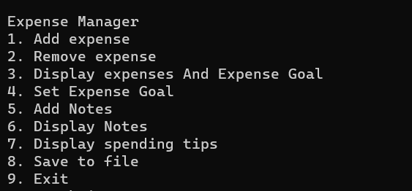

Adding Expense

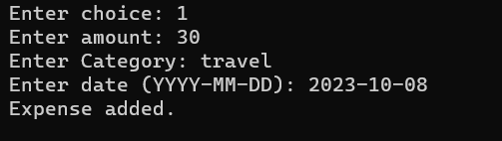

Remove Expense

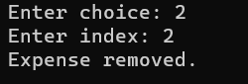

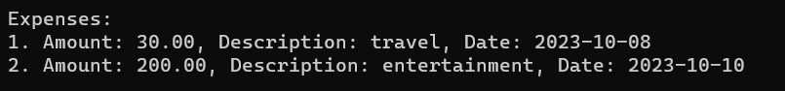

Display Expenses And Expense Goal

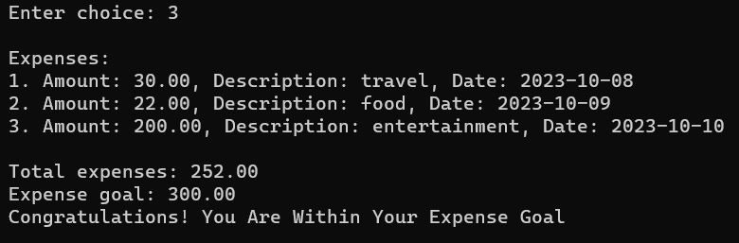

Set Expense Goal



Add Notes

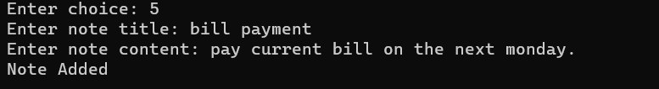

Display Notes

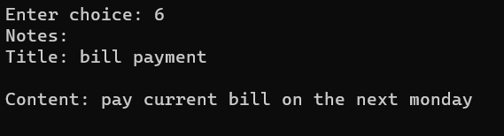

Display Spending Tips

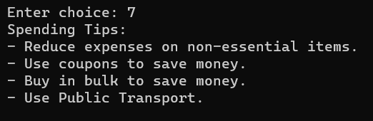

Save Expenses On File

